

Guide for Setting up NWB/CIShell Developmental Environment

(Part of DEVELOPER'S GUIDE)

Cyberinfrastructure for Network Science Center
Indiana University

Weixia (Bonnie) Huang
Bryan Hook
Katy Börner

Last revised: October 9, 2007



1. Install Eclipse SDK and Subclipse Plug-in 3
1.1. Install JAVA 3
1.2. Install Eclipse SDK 3.2 or 3.3 3
1.3. Install Subclipse 3
1.4. Change Preferences 6
2. Specify Repositories 8
2.1 Switch View to SVN Repository Perspective 8
2.2 Setup CIShell and NWB Repositories 8
2.3 Setup Eclipse CVS Repository 10
3. Check out code 11
3.1 Check Out CIShell Code 11
3.2 Check Out NWB Code 12
3.3 Check Out OSGi Plug-ins 13
4 Manage Plug-ins in Package Explorer at Eclipse SDK (optional) 14
4.1 Create Working Sets 14
4.2 Update Configuration 14
5 Acknowledgment 15

- Install Eclipse SDK and Subclipse Plug-in
  - Install JAVA
Install Java 1.5+ and check the run time version. The following example is taken from Windows:
C:\>java -version
java version "1.5.0_10"
Java(TM) 2 Runtime Environment, Standard Edition (build 1.5.0_10-b03)
Java HotSpot(TM) Client VM (build 1.5.0_10-b03, mixed mode)

  - Install Eclipse SDK 3.2 or 3.3
Download eclipse SDK 3.3 from http://download.eclipse.org/eclipse/downloads/drops/R-3.3-200706251500/index.php. For instance, the downloaded file for Windows is eclipse-SDK-3.3-win32.zip. Then unzip the file to a directory.
Note: We recommend setting up the NWB/CIShell development environment based on eclipse SDK3.2 or 3.3. Upgrading from 3.1 to 3.2+ using eclipse’s update manager won’t work. You should install a fresh copy of eclipse, either version 3.3 or 3.2.

  - Install Subclipse
NWB and CIShell repositories use subversion (http://subversion.tigris.org)-- a version control system to manage code. To check in/out code from NWB and CIShell repositories, it requires installing Subclipse – a plug-in providing support for Subversion within the Eclipse IDE. The Subclipse plug-in is available at http://subclipse.tigris.org/servlets/ProjectDocumentList?folderID=2240&expandFolder=2240&folderID=0 . The following instructions have been updated based on the instructions at http://subclipse.tigris.org/install.html.

1.3.1 Begin the installation from the Eclipse Help menu (see Figure 1).
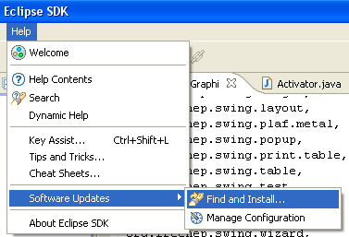
Figure 1: Find and Install in Help Menu

1.3.2 Figure 2 shows the screen as it initially comes up. In this case you will need to change the radio button to indicate that this is a new install.
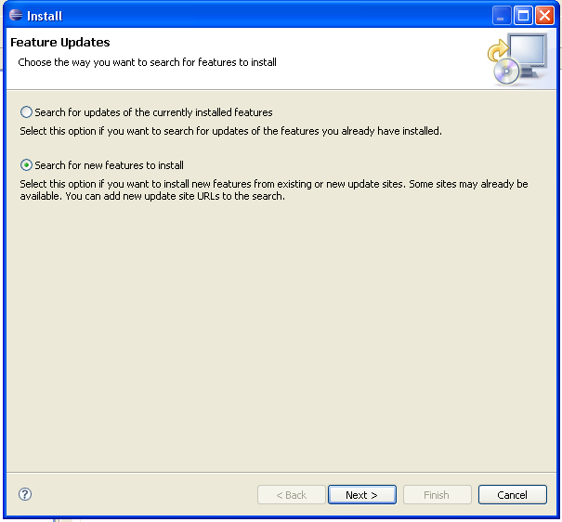
Figure 2: Search for New Features Selection

1.3.3 Figure 3 will vary depending on the features you have installed already. You want to click on the New Remote Site button. If you are behind a proxy and the Eclipse install mechanism does not work, then you can download a zipped version of the update site and then click the New Local Site button instead.
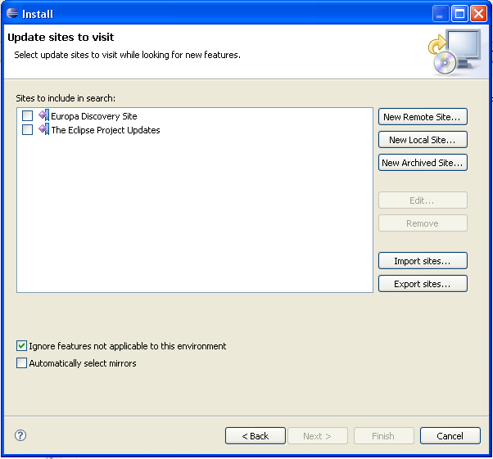
Figure 3: Selecting Update Sites

1.3.4 Figure 4 shows the New Remote Site dialog, filled in with the correct information to install Subclipse
Name: Subclipse 1.2.x (Eclipse 3.2+)
URL: http://subclipse.tigris.org/update_1.2.x

Name: Subclipse 1.0.x (Eclipse 3.0/3.1)
URL: http://subclipse.tigris.org/update_1.0.x
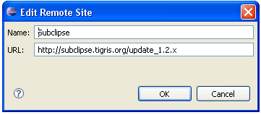
Figure 4: Edit Remote Site

1.3.5 In the updates window (see Figure 5), only check Subclipse Plugin → Subclipse 1.2.4.
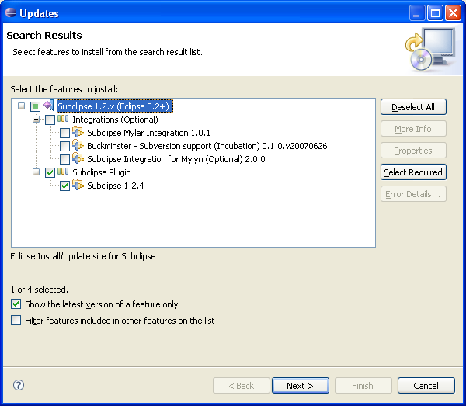
Figure 5: Updates Window
1.3.6 Click the button to accept the license agreement (Figure 6).
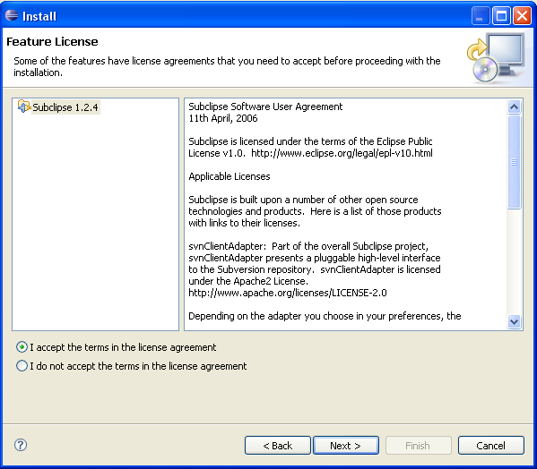
Figure 6: License Agreement

1.3.7 Click the button to finish the installation.

  - Change Preferences
Change the SVN preference option by going to Window -> Preferences, see Figure 7.
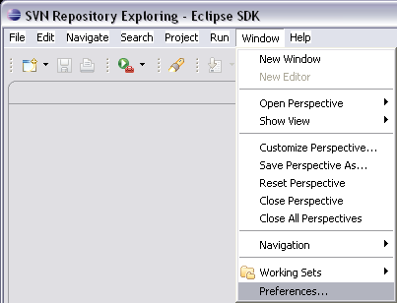

Figure 7: Window -> Preferences

Note: You must change SVN interface from JavaHL (by default) to SVNKit (PureJava), see Figure 8.
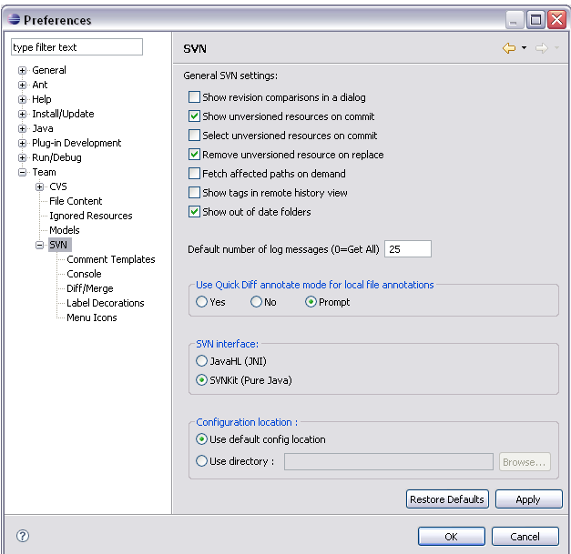

Figure 8: Changing from javaHL to SVNKit

- Specify Repositories

  - Switch View to SVN Repository Perspective
click on Window -> Show View -> SVN, see Figure 9.
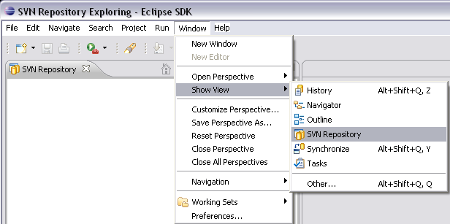

Figure 9: Changing View to SVN Repository
  - Setup CIShell and NWB Repositories
Click the add icon in the SVN Repository window and specifying the respective SVN repository’s URL (see Figures 10 & 11).

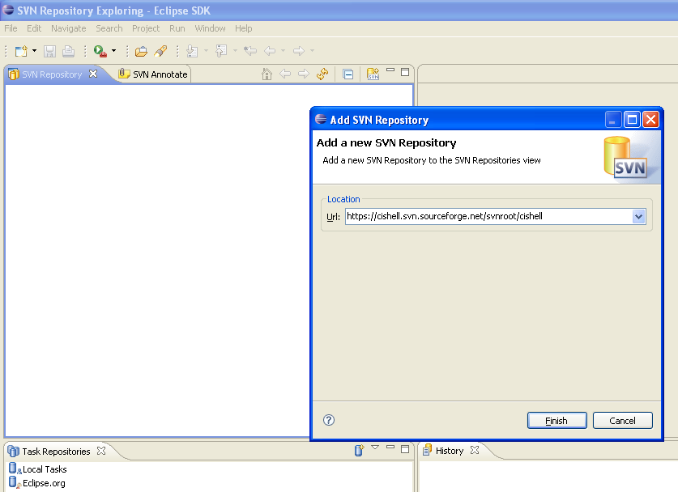
Figure 10: Adding a new SVN Repository

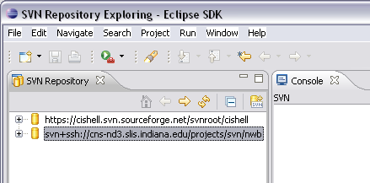

Figure 11: Available SVN Repositories

CIShell repository URL is https://cishell.svn.sourceforge.net/svnroot/cishell
Note: To check in/out code from CIShell repository, you need to register an account at sourceforge.net

For the non-IU developers, NWB repository is https://cns-nd3.slis.indiana.edu/svn/nwb. The code can be browsed and downloaded from there (please skip the rest of this section and jump to 2.3)

For NWB development team members with IU accounts, NWB repository URL is svn+ssh://cns-nd3.slis.indiana.edu/projects/svn/nwb.

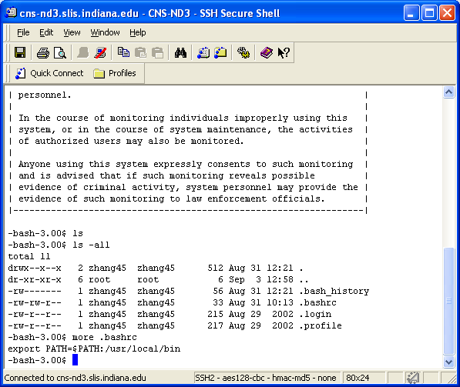
Figure 12: .bashrc file content
Note 1: Before adding the NWB repository, set /usr/local/bin to your path in the .bashrc file after you login to the host cns-nd3.slis.indiana.edu. Place this file in your home directory on cns-nd3 [Figure 12] (it will be invisible once moved there; use “ls –al” to display hidden files and use “more .bashrc” to view the file contents; use vi, pico, or other tools to edit the file content).

Note 2: To login to cns-nd3 zone from a Windows machine:
Download SSH Secure Shell from http://iuware.iu.edu/title.aspx?id=36
Enter host name: cns-nd3.slis.indiana.edu
Logon with your network id and password phrase

  - Setup Eclipse CVS Repository
To check out some required bundles from the eclipse repository, you will need to setup a cvs repository as well. Switch to CVS Repository view and add a new CVS Repository (Figure 13).
Here is the reference link for the CVS repository configuration:
http://wiki.eclipse.org/index.php/CVS_Howto#CVS_Repository_Paths

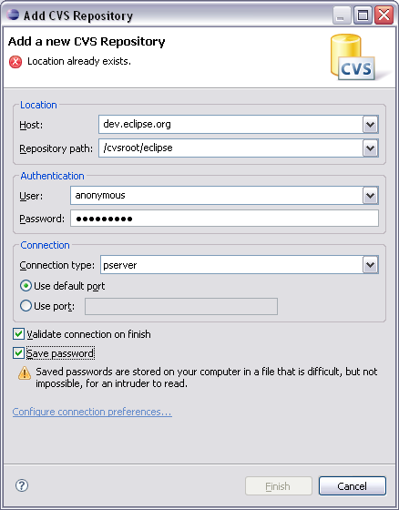

Figure 13: Add new CVS Repository
- Check out code
  - Check Out CIShell Code
Check out CIShell code from the SVN repository at https://cishell.svn.sourceforge.net/svnroot/cishell.
    - To get the head version of CIShell APIs and reference GUI (generic component to build the NWB tool), go to the trunk folder and then check out the following packages: (Figure 14)
- All packages under /trunk/core
- All packages under /trunk/clients/gui
- All packages under /trunk/libs
- Selective packages shown in the following figure under /trunk/templates
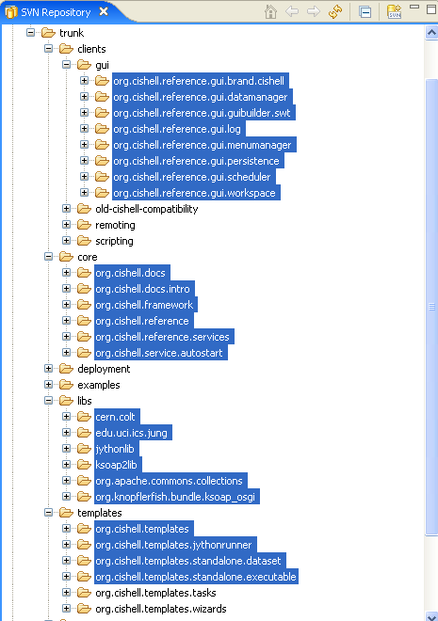
Figure 14: Bundles to check out from SVN Repository

Note: Make sure that you are checking out each package as a separate project. Checking out folders such as /trunk/core or /trunk/clients/gui to the eclipse workspace does not work.
Hint: You can also select multiple packages to check them all out at once.
- To get the build/release version of CIShell, please go to /tags. (There’s a problem to tag cishell release on sourceforge repository so far.)
  - Check Out NWB Code
Check out all or some sample algorithms from NWB’s SVN repository at svn+ssh://cns-nd3.slis.indiana.edu/projects/svn/nwb or https://cns-nd3.slis.indiana.edu/svn/nwb
  - To get the head version of various network modeling, analysis and visualization algorithms in the NWB tool, go to the trunk folder and then check out the following packages:
- All packages under /trunk/plugins/libs
- All packages under /trunk/plugins/converter
- All Packages under /trunk/plugins/shared
- Some packages under /trunk/plugins/analysis, /trunk/plugins/modeling, /trunk/plugins/preprocessing, and /trunk/plugins/visualization,
- A list of suggested sample algorithms will be provided soon.
Note: Make sure that you are checking out each package as a separate project (an example is shown in Figure 15 & 16). Checking out folders such as /trunk/plugins/analysis or /trunk/plugins/modeling to the eclipse workspace does NOT work.
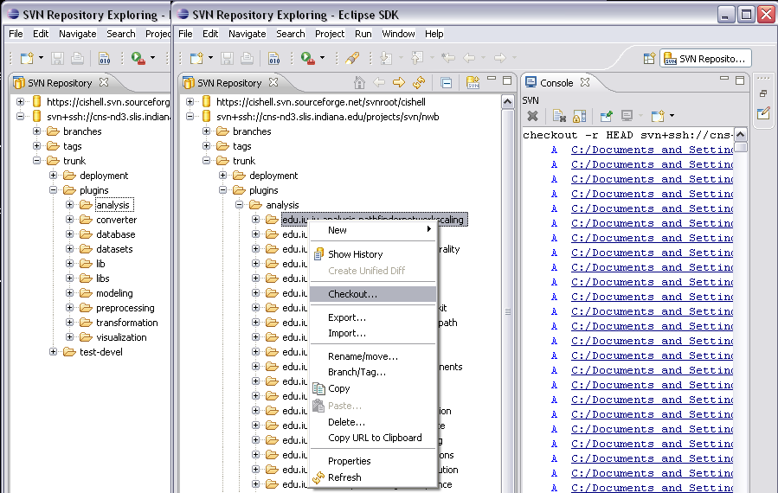

Figure 15: Directory structure of plugins and how to check out the files
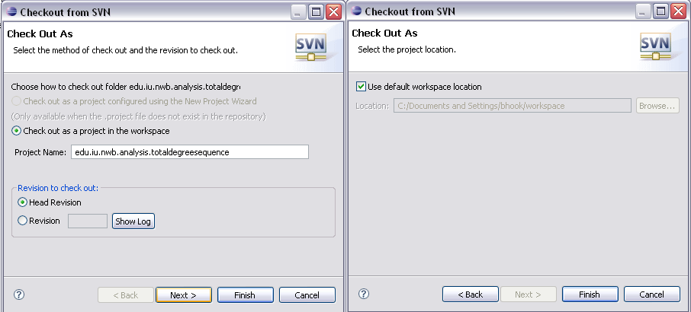

Figure 16: Checkout prompts
    - To get the build/release version of the NWB tool, please go to /tags, select a release version to check out packages.
    - For outside developers, we will make nwb’s SVN repository accessible and the source code can be downloaded through https (Jon is working on this setup).
  - Check Out OSGi Plug-ins
From the eclipse CVS repository, check out the following services:
- declarative service (org.eclipse.equinox.ds)
- event (org.eclipse.equinox.event)
- log service (org.eclipse.equinox.log)
- metatype service (org.eclipse.equinox.metatype)
- servlet (org.eclipse.equinox.servlet.api)
- useradmin (org.eclipse.equinox.useradmin)

- Manage Plug-ins in Package Explorer at Eclipse SDK (optional)
  - Create Working Sets
Create a bunch of working sets to organize all packages in the workspace, see Figure 17.
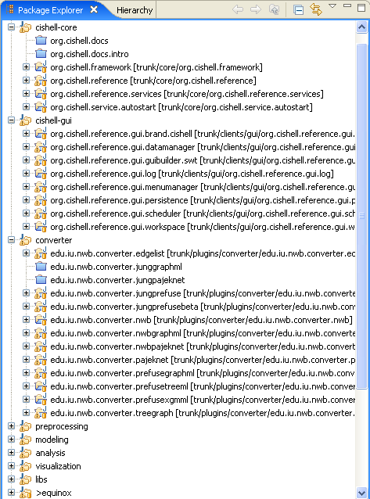

Figure 17: Working Sets

  - Update Configuration
Make sure to add and check “bin” and “build” directories under “Ignore Patterns” before making build, see Figure 18.
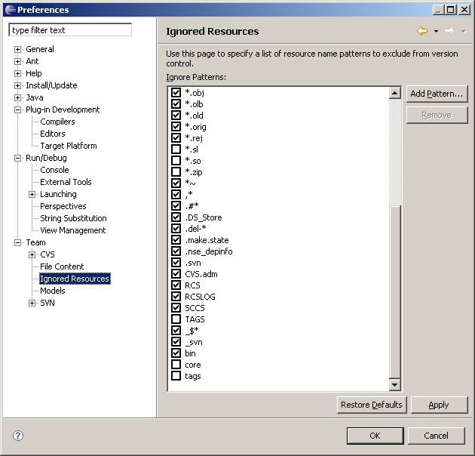

Figure 18: Checkout prompts

- Acknowledgment
The NWB cyberinfrastructure is supported in part by the 21st Century Fund and the National Science Foundation under grants No. IIS-0238261 and IIS-0513650.

Thanks Heng Zhang and Megha Ramawat’s contribution to this documentation.

